Logo by Laura Leclerc

Requirements Document

Valentin Bonnet | Pier-Luc Gagnon | Etienne Perot

Table of Contents

Note: It is highly recommended to read this document in colors online:
http://tinyurl.com/everVoidRequirements

- Introduction
1.1. Purpose …..................................................................................................... 3
1.2. Scope ............................................................................................................ 3
1.3. Definitions, acronyms and abbreviations .................................................. 3
1.4. References ................................................................................................... 4
1.5. Overview of document ................................................................................. 4
- Overall description
2.1. Product perspective .................................................................................... 5
2.2. Product functions ......................................................................................... 6
2.2.1. Use Case Diagram ....................................................................... 7
2.3. User characteristics ................................................................................. 7
2.4. Constraints ................................................................................................... 8
2.5. Assumptions and dependencies ............................................................... 8
2.6. Risks and Apportioning of requirements ................................................... 8
- Specific requirements
3.1. User Interface requirements .......................................................................... 8
3.2. Structural requirements
3.2.1. Distributed Architecture ...................................................................... 19
3.2.2. Environment Model ............................................................................. 20
3.2.3. Concept Model .................................................................................... 22
3.3. Behavioural requirements 3.3.1. Use Case Templates .......................................................................... 23
3.3.2. Operation Model .................................................................................. 30
3.3.3. Protocol Model ..................................................................................... 32

1. Introduction
everVoid is a space based video game in which player(s) vie for control of the galaxy; it is a turn-based strategy game win which each player submits his/her turn simultaneously. The project is being developed by Etienne Perot, Valentin Bonnet and Pier-Luc Gagnon for McGill’s Software Engineering Project course (COMP 361), spanning both the fall 2010 and winter 2011 semesters.

1.1 Purpose
This Software Requirements Specification (SRS) provides a description of all the functions and specifications of the everVoid multi-player turn-based space game; it is based on the IEEE 830 Standard.

1.2 Scope
The project is composed of two main components: a Client and a Server. Clients connect to everVoid Server in order to play a game. The Server is tasked with all game calculations while the Client simply relays information between the Player and the Server. For the purpose of this document, the Client and Server are considered a single System, which provides the user with the game experience. Interactions specific to Host - Server or Player - Client are discussed and marked as such.

1.3 Definitions, acronyms and abbreviations
1.3.1 Definitions
- Player: User playing an everVoid game by using the everVoid Graphical interface.
- Host: User hosting an everVoid server, has access to a console and can issue commands to the server. Can be a Player as well.
- Client: The everVoid Graphical Interface, capable of displaying a game state, connecting to an everVoid Server, and sending moves to the Server.
- Server: an everVoid server, accepting lobby creations, capable of accepting player move submissions and calculating the next turn.
- Lobby: Small virtual room where players wait until a game is launched.
- Action: a type of play that players can perform during a game

1.3.2 Glossary
Term | Definition
Ack | Acknowledgement
A.I. or AI | Artificial Intelligence (also denotes robots)
API | Application Programming Interface
(G)UI | (Graphical) User Interface
IEEE | Institute of Electrical and Electronics Engineers
JVM | Java Virtual Machine
LAN | Local Area Network
SRS | Software Requirements Specification
TCP | Transfer Control Protocol
UML | Unified Modelling Language

1.4 References
- IEEE Recommended Practice for Software Requirements Specifications. New York: Institute of Electrical and Electronics Engineers, 1998.

1.5 Overview
Chapter 2 provides a description of the everVoid project, its purpose, and flow. It is mostly textual and provides information as to what interactions a user could have with the everVoid game. Chapter 3 contains diagrams detailing the structure and state of the everVoid System, which were created following UML 2.0 specifications. This section details the process involved in each interaction mentioned in section 2.

2. Overall description
This section describes the overall scope, functionality, and constraints of the everVoid project.
2.1 Product perspective
everVoid will use external libraries for certain tasks (i.e. for graphics and communication). The Game logic and state representation will however be entirely constructed by the everVoid development team.

everVoid will feature a number of Graphical User Interfaces to allow the Player to communicate his intent to the the game:
- A root Main Menu will appear first when the game is launched, giving the player the possibility to join a lobby, change settings (volume, player name, screen resolution, etc.) and quit.
- A Lobby interface which allows the players to communicate with one another while waiting for other players. This interface also allows the Lobby Master to choose a map, add additional players/AIs, load a game from a save file, and start the game.
- A game User Interface resembling the interface of common mainstream real-time-strategy games (for familiarity and intuitiveness) allowing the player to issue commands to units, control camera movement, access in-game menus (such as the research menu, planet menu, etc.) and communicate with other players.
- Game Menu that enables saving, enabling or disabling sound and/or music and leaving the game (i.e. returning to root main menu).
- Multiple in-game views such as Research view, Planet view, Solar System view, and Galaxy view. These will allow the user to change state of their respective game elements.

Because everVoid will be written in Java, it will make heavy use of the Java Virtual Machine and thus Java must be installed on the machine to play. For this same reason, everVoid will work properly on operating systems with Java support as it will not interface with them directly.

2.2 Product functions
This section provides a summary of the different functions available to users and hosts to allow them to control the flow of the everVoid software. For convenience, a list of the use cases is provided, followed by the actual use cases diagram in section 2.2.1. The full use cases can be found later in section 3.3.1.

Summary level:
- Play a Game
- Run a Server
User Goal level:
- Create a Server
- Set up a Lobby
- Join a lobby
- Start a Game
- Save a Game
- Load a Game
- Play a Turn
- Leave a Game
Subfunction level:
- Send a chat message
- Kick a player
- Change Server Status
2.2.1 Use Cases
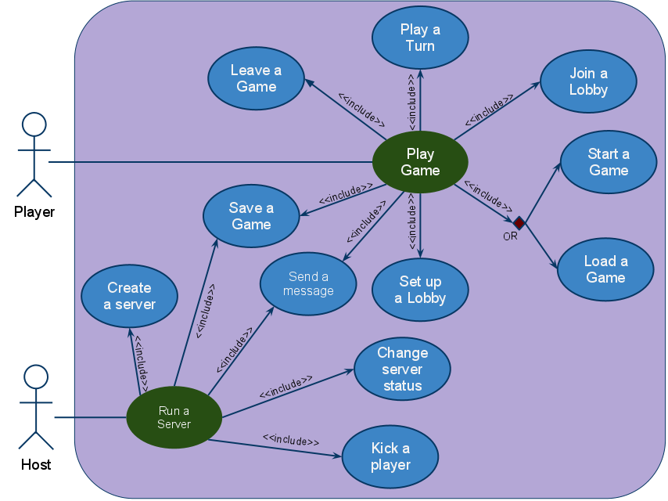
Figure 1: everVoid use case diagram
This use case diagrams represents different goals that different users might have during the execution of the software. The Players’ main success scenario is playing a game, while the Hosts’ is running an everVoid server; both involves multiple possible sub-cases.

2.3 User Characteristics
Players are expected to be knowledgeable about how the Internet works and know what a computer address is (in order to play multi-player). They are also expected to have some basic game knowledge. The interface will use elements established in many games, players are assumed to be comfortable with these features.

The hosts are expected to be very knowledgeable about how the Internet and client/server models work, as well and know how to open, edit and save server configuration files (text files). They are also expected to know how to use a console to control a server.

2.4 Constraints
Because memory and processing powers are limited, certain aspects of the game might have to be limited in order to provide the user with a pleasant game experience. For instance, the number of units a player can possess will have to be limited to prevent overloading the computer.

To prevent cheating, the validation of player actions will be done on the server side. If cheating is caught the Server will save the previous game state, warn all clients, and proceed to end the game.

Certain factors are outside of the control of the everVoid game (ie. disconnection from the Internet, computer shuts down...). To mitigate the risk of untimely shutdown, the game will save state to a temporary file periodically.

2.5 Assumptions and Dependencies
It is assumed, and vital for the application, that the Java Virtual Machine is installed on the computer trying to run everVoid. The final product will bundle the JVM with the installer, avoiding this issue.

The product relies on the jMonkeyEngine library, which will also be bundled with the product.

The ability to connect to a live everVoid Server is also assumed for the Client, i.e. no firewall or other applications are preventing the client and the server from communicating.

2.6 Risks and Apportioning of requirements
Lack of experience of the development team is certainly a big factor in the development of everVoid. Time constraints might lead to certain features getting delayed until future versions of the game. Because the project is also planned by this same inexperienced team, project expectations might have been set too high, leading to features having to be removed, delayed or simplified.

In particular, non-gameplay-critical features such as sounds might not be ready in time, or compromises might be made regarding varying AI personalities. Additionally, certain units or buildings with more complex logic (transport ships, movable base station) might also not be implemented in the first release.
If necessary, the Galaxy View might also not be implemented, as all other views feature a minimal version of the galaxy view, bypassing the need for a full-screen one without reducing user functionality.
3. Specific requirements
This section describes some implementation requirements about the everVoid System.

3.1 User Interface requirements

Main Menu
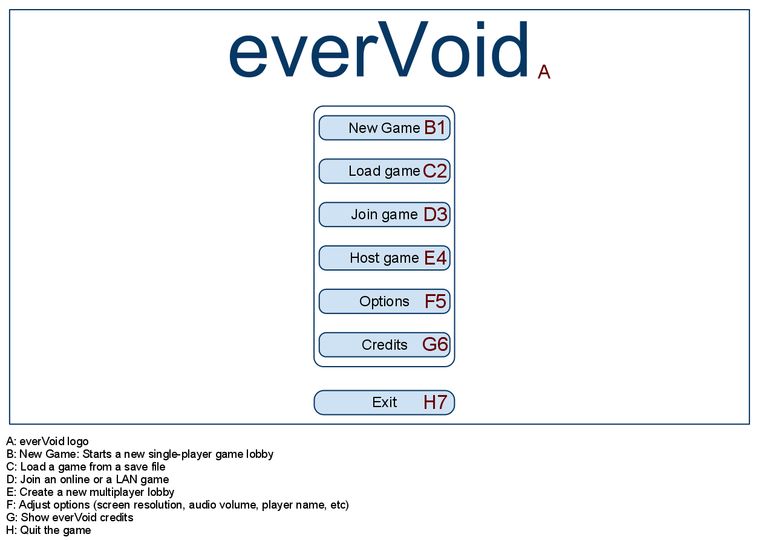
Figure 2: everVoid interface mockup: Main Menu

Lobby Interface
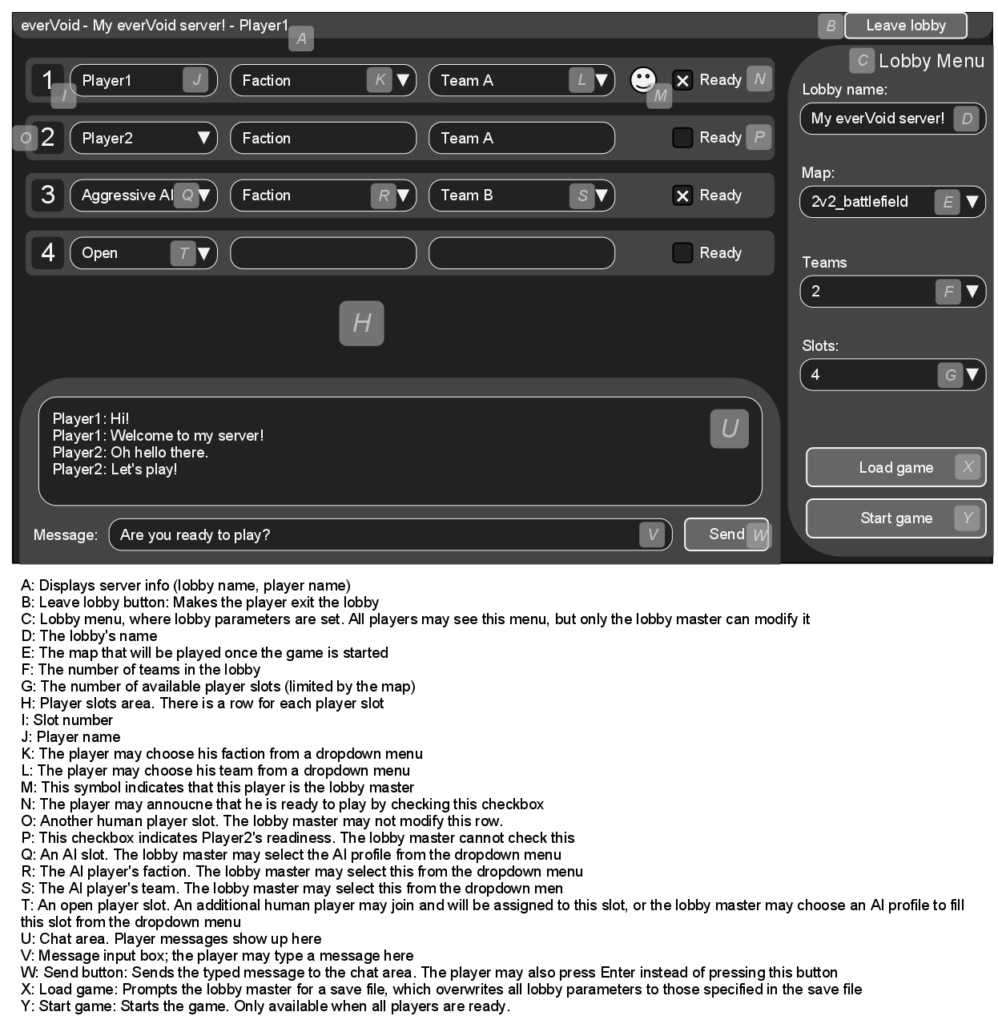Figure 3: everVoid interface mockup: Lobby

Galaxy View

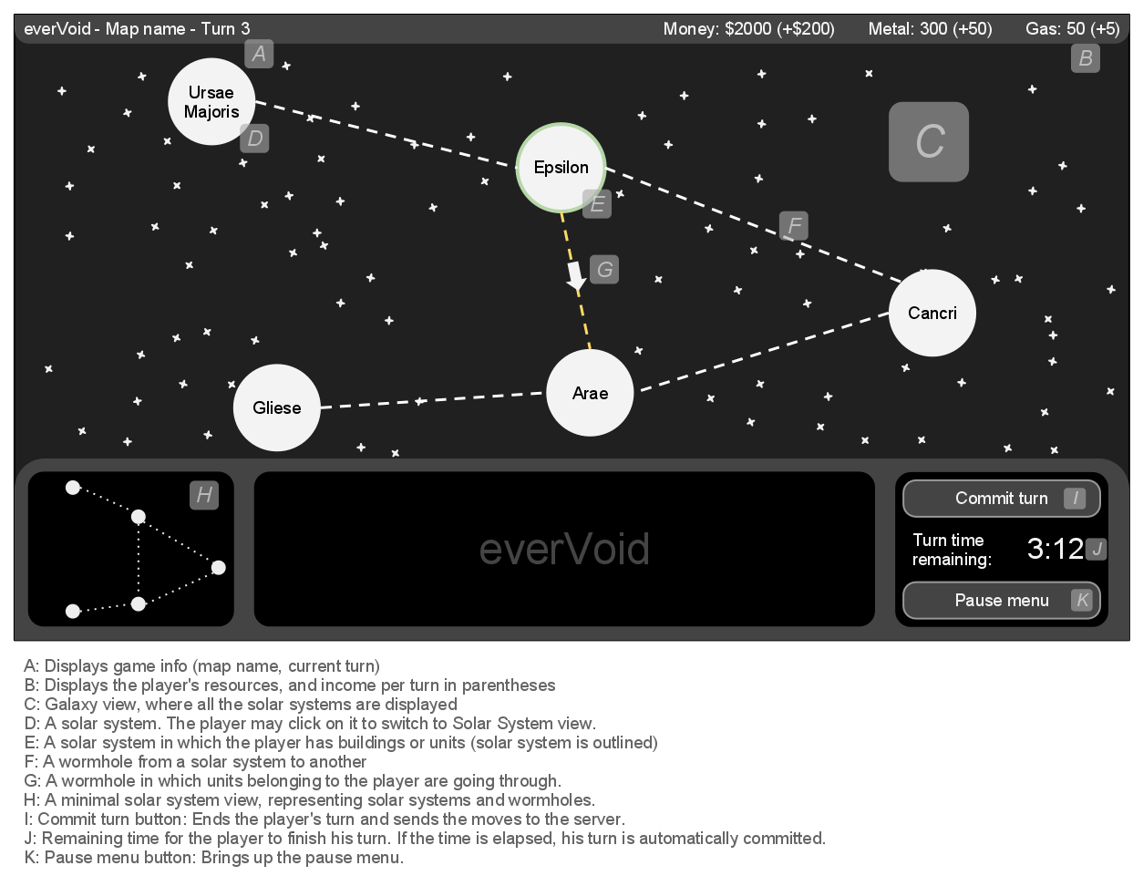
Figure 4: everVoid interface mockup: Galaxy view

Solar System View

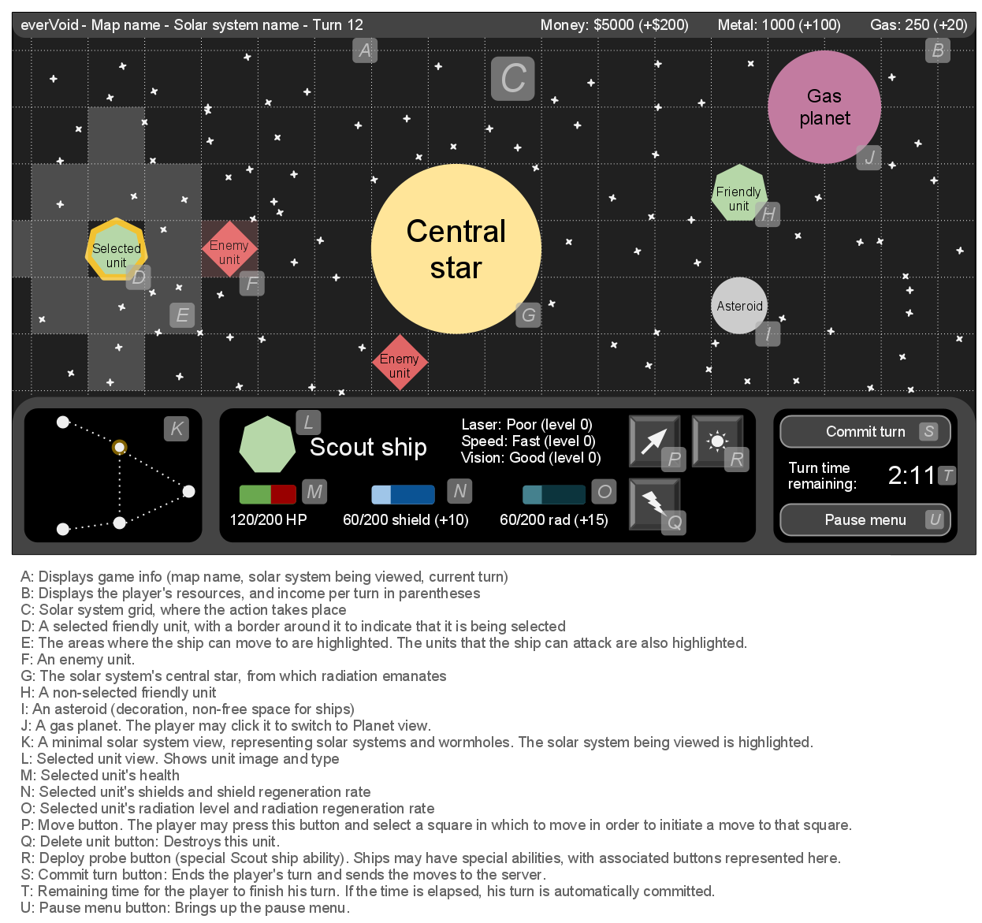
Figure 5: everVoid interface mockup: Solar System view

Planet View

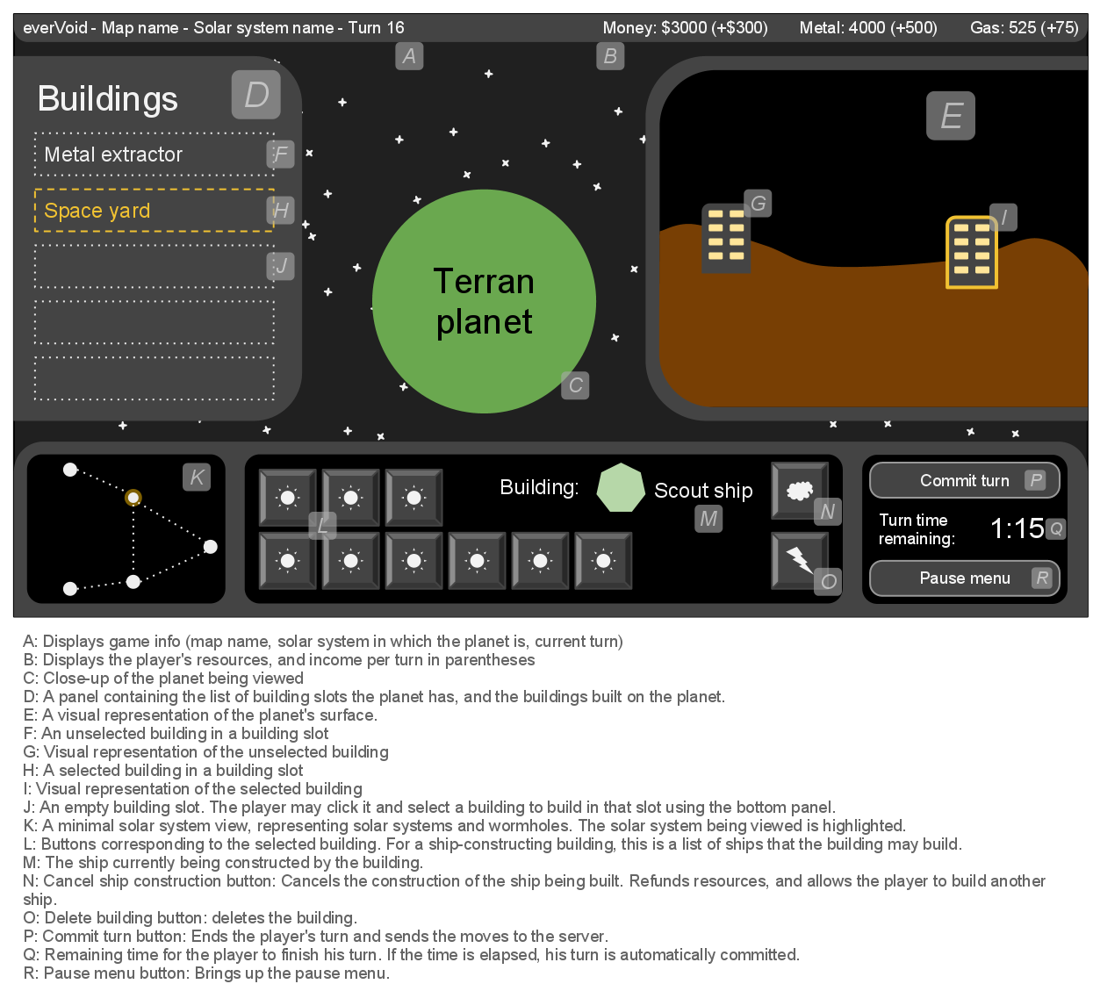

Figure 6: everVoid interface mockup: Planet view

Research View

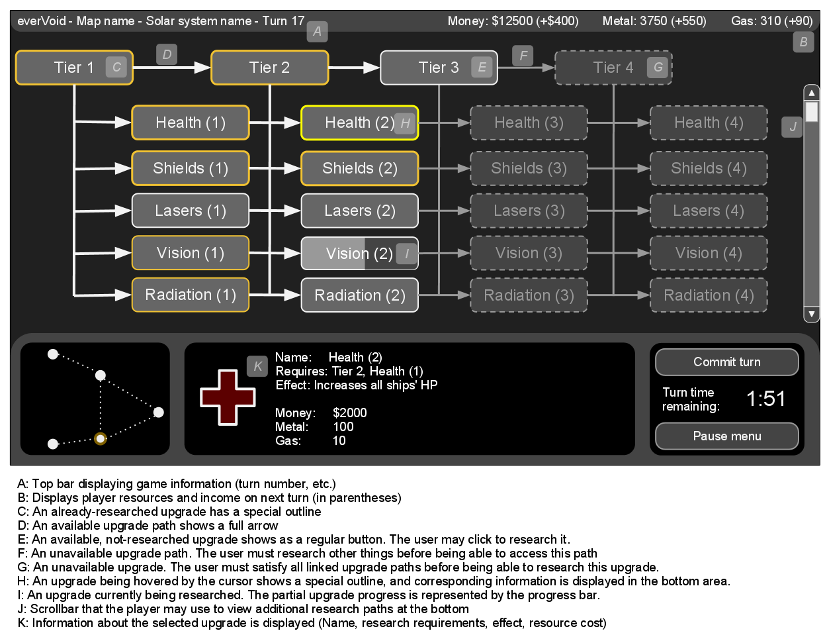

Figure 7: everVoid interface mockup: Research view

In-game Chat Message

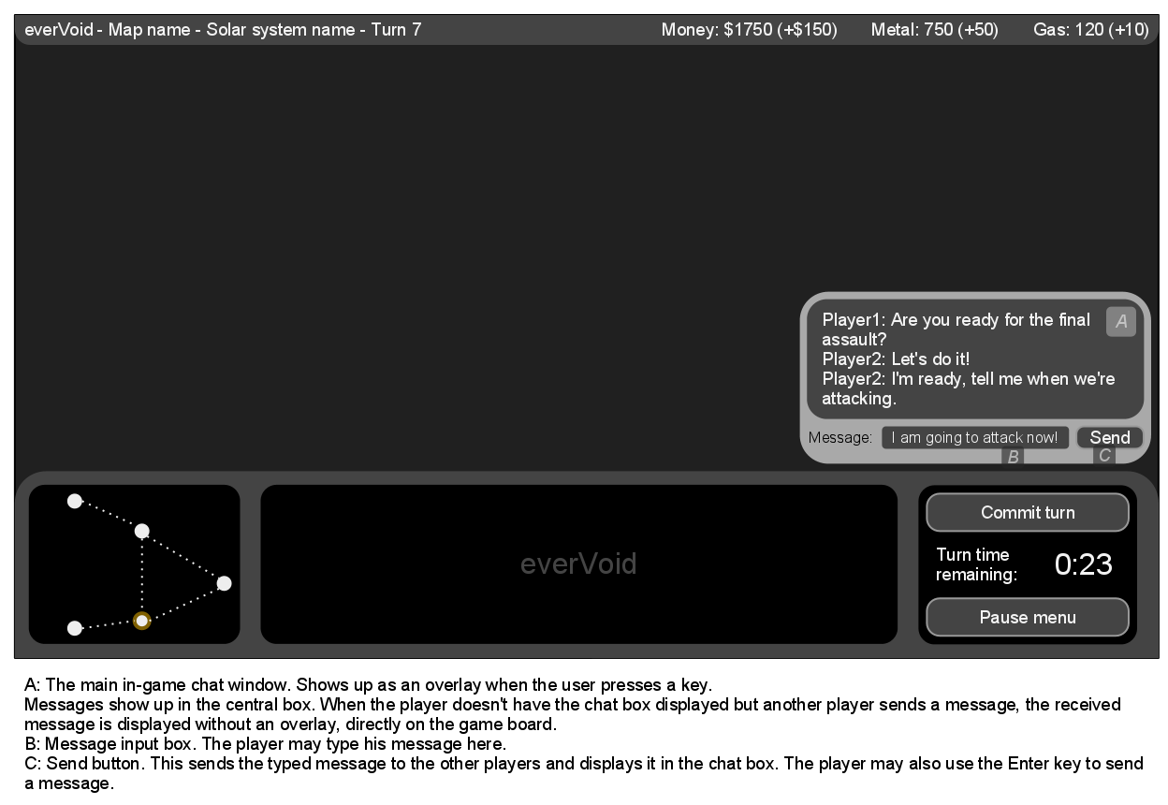

Figure 8: everVoid interface mockup: In-game chatting

Pause Menu

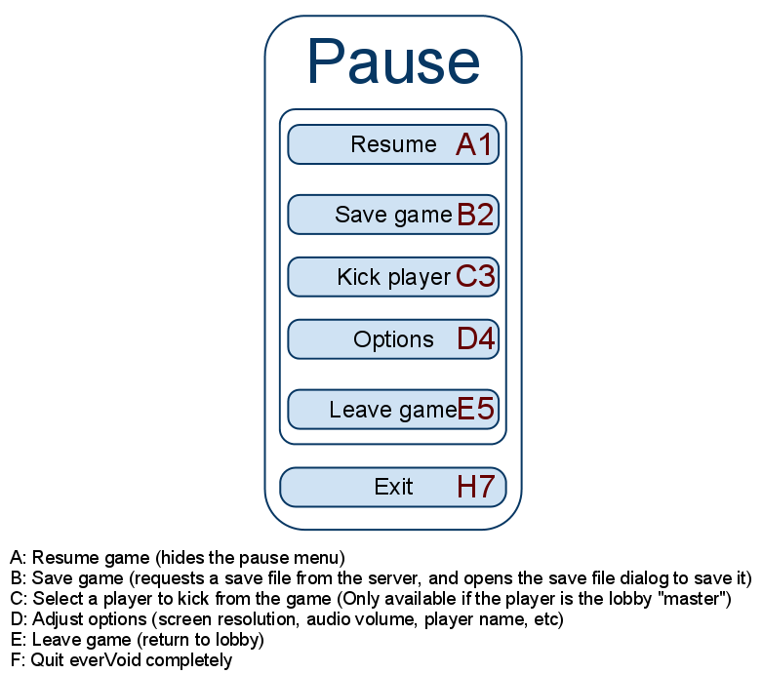Figure 9: everVoid interface mockup: Pause menu

Load game
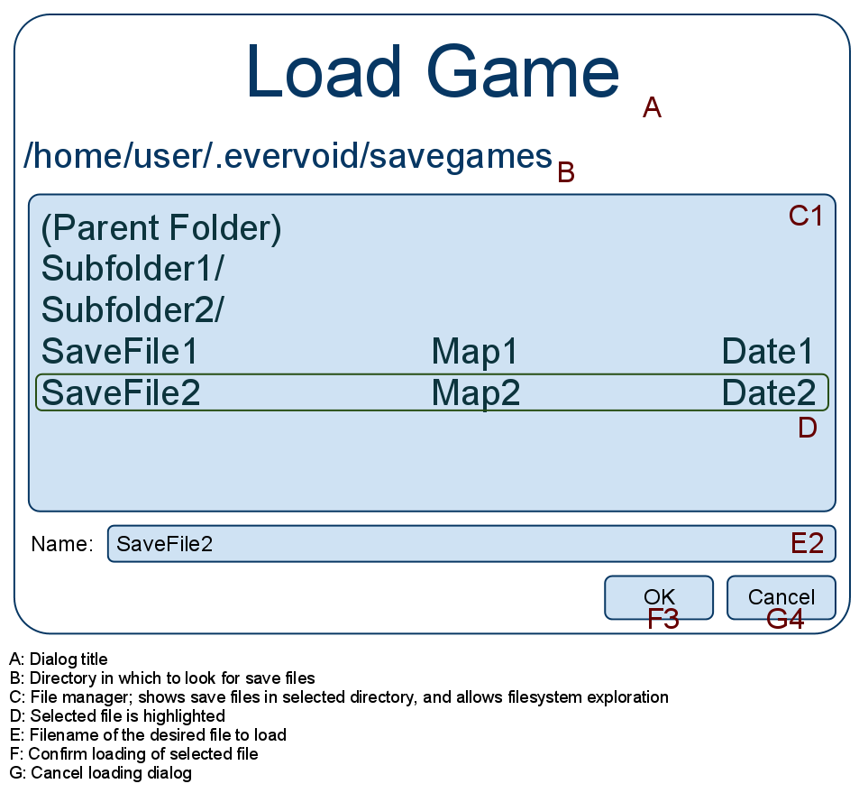Figure 10: everVoid interface mockup: Load game dialog

Save Game

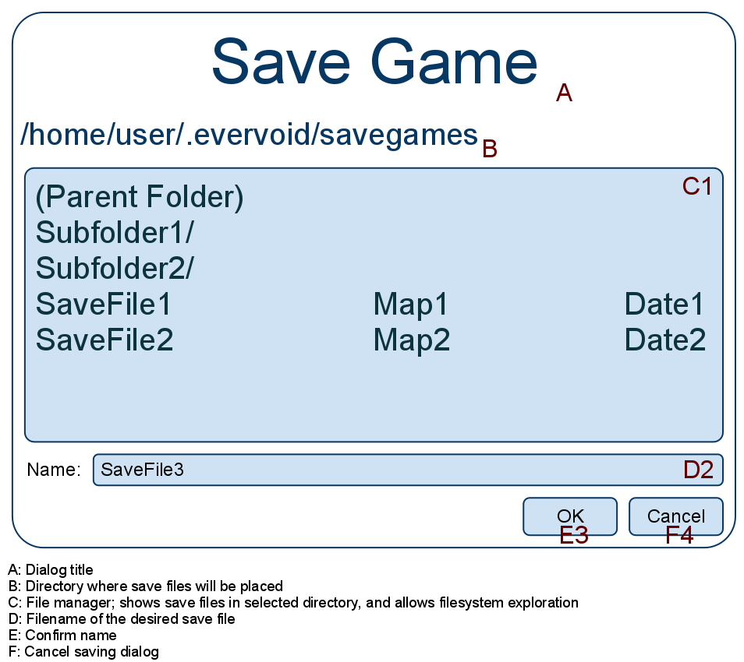Figure 11: everVoid interface mockup: Save game dialog

3.2 Structural requirements
3.2.1 Distributed Architecture

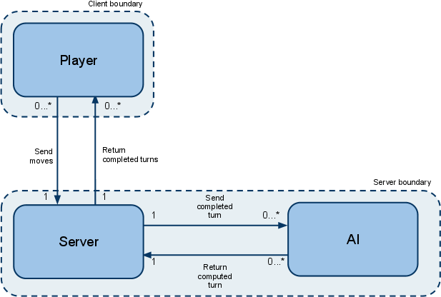
Figure 12: everVoid client/server boundaries
This diagram highlights the structural boundaries between the client-server communication.

To support multi-player interactions, everVoid will be built using a client/server distributed architecture. The client executable contains the full game engine and the graphical user interface. The server executable will not contain a graphical user interface, all the interaction are made using text commands through a console. In order to allow the server to verify turn validity, it will contain a copy of the game engine. Checking that the local player’s turn is valid is not necessary on the client side, because the Graphical User Interface will not allow players to make invalid moves. However, each client will check other players’ turns. Both client and server can save and load the game, but only the server is able to load a game in the current lobby (player will be able to load the game offline). Although the server is intended to run on a dedicated computer, it is entirely possible to run both client and server programs on the same machine, to allow offline play or simply host a server and be able to play on it using the same computer.

3.2.2 Environment Model
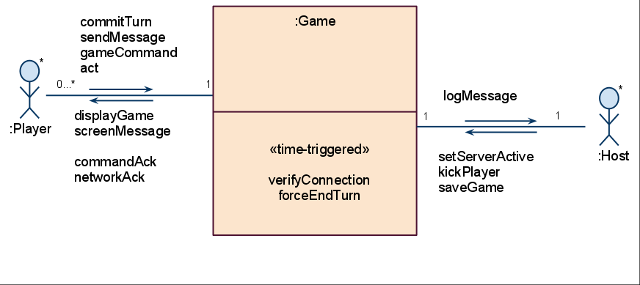
Figure 13: everVoid environment model
This diagram describes the possible interactions between the System and external actors.

The different commands and their parameters are described below:
Input Messages
- commitTurn(actions: List<Action>)
- sendMessage(message: String, player: Player)
- gameCommand(command: Command, parameter: Parameter) (This is an abstraction for different possible game commands, such as etc.)
- act(action: Action)
- setServerActive(active: Boolean)
- kickPlayer(player: Player)
- saveGame(location: String)

Output Messages
- displayGame() (Update the User Interface to reflect what is currently happening)
- screenMessage(message: String)
- commandAck() (Acknowledges the user’s command visually)
- networkAck()
- logMessage(message: String) (Any message to be shown in the console)

Message types
- Action: An action that a player may perform during a turn that is related to the actual game world.
  - Action Types: {move ship, attack, initiate research, construct a building, construct a ship, use a ship ability, colonize a planet, use hyperjump}
- Command: A task that a player may execute while in everVoid.
  - Command Types: {create a server, change server status, join a lobby, leave a lobby, start a game, end a game, save a game, load a game, quit}

3.2.3 Concept Model

The following UML diagram (figure 14) describes the internal representation of the everVoid game state. The Game object represents the game itself, and contains Players and Solar Systems, themselves containing references to other objects, representing the whole game state. ShipContainer is an interface which lets Solar Systems and Wormholes contain Ships. The entire Game State can be serialized and sent over the network from Client to Server. Note that Enumeration types (ship types, resource types, building types, research types) are defined statically, thus not part of the game state.

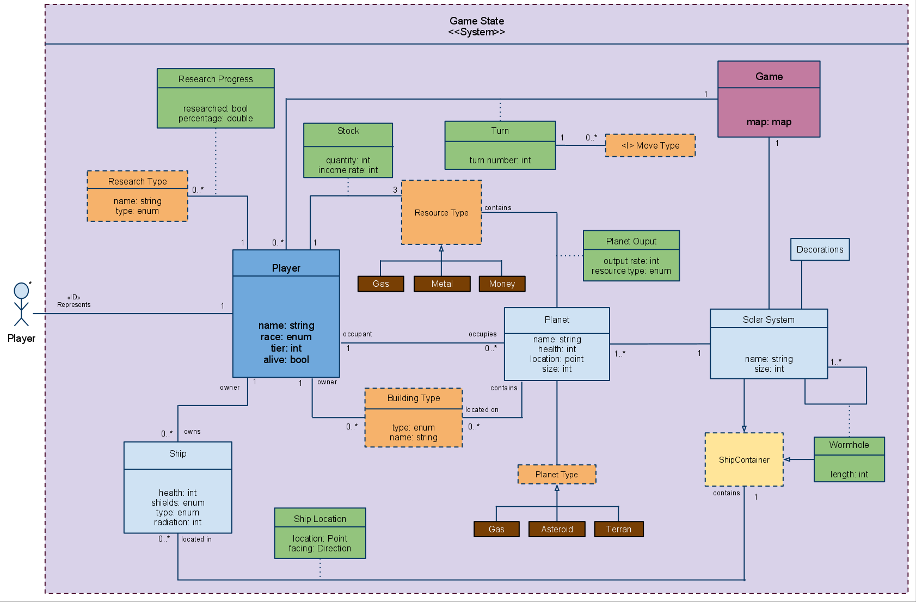
Figure 14: everVoid concept model

A bigger version of the diagram can be found at: http://tinyurl.com/everVoidConceptModel

3.3 Behavioural requirements

3.3.1 Use Cases
Use Case: Play a Game
Scope: Entire System
Level: Summary Level
Intention: The Player wants to play a game of everVoid.
Multiplicity: Can only play one Game
Primary actor: Player
Secondary actors:
Precondition: Game is installed on Player’s machine.
Main success scenario:
Steps 4, 5, 6 can be repeated any number of times and can be done in any order
- Player launches the Client.
- Player joins a Lobby.
- Player starts the Game.
- Player plays a turn.
- Player sends a message.
- Player saves the Game.
- Player leaves the game.

Extensions:
2a. Player does not want to join an existing Lobby, go to set up a Lobby and continue with step 3.
3a. Player informs the System that he wants to load a game, go to the Loading a Game use case. Return to step 4.

Use Case: Run a Server
Scope: Server Subsystem
Level: Summary Level
Intention: A Host wishes to create a server on which players can connect to play a game
Multiplicity: Only one server per machine
Primary actor: Host
Secondary actors:
Precondition: Host is connected to the Internet and has properly configured the Server files
Main success scenario:
Steps 2, 3, 4, 5 can be repeated any number of times and can be done in any order
- Host creates a Server
- Host saves the game
- Host changes server status
- Host sends a message to one or all of the players
- Host kicks a player

Extensions:
1a. Server is already running on the machine, use case ends in failure.

Use Case: Create a Server
Scope: Server-side
Level: User Goal
Intention: A host wishes to create a dedicated everVoid server.
Multiplicity: Can only create one Server
Primary actor: Host
Secondary actors: Console
Precondition: None
Main success scenario:
The Host wishes to create a standalone, dedicated everVoid Server.
- The Host creates a configuration file for the System (server name, server port, maximum number of players, etc.)
- The System launches the server.
- The System loads the configuration file.
- The Host informs the System that he wants to activate the server (make it public).
- Players may now connect to the Host’s dedicated server.

Extensions:
3a Server refuses to start if the configuration file is malformed or contains invalid values. Use case ends in failure.

Use Case: Set up a Lobby
Scope: Client-side: Lobby
Level: User Goal
Intention: The user wants to create a lobby on a server.
Multiplicity: Can only create one Game at a time
Primary actor: Player
Secondary actors: Lobby Interface
Precondition: Server must be active; no game in progress
Main success scenario:
Player requests server to create a new game given some information. The new Game is then returned and can be played.
- Player joins a Lobby as “lobby master”.
- Player sets Lobby variables (map, number of players, name, etc).
- Player waits for Lobby to fill (players may join the lobby, and Player may add AIs in the player slots).

Extensions:
2a. System ascertains that the provided game name is invalid.
2a.1. Game Engine informs the player and changes back the lobby name (step 2).
2b. Player informs the system that he wants to load a game, go to Loading a Game use case

Use Case: Join a Lobby
Scope: Client-side: Lobby
Level: User Goal
Intention: The player wishes to join a lobby that is already hosted.
Multiplicity: Multiple users per server.
Primary actor: Player
Secondary actors: Lobby interface
Precondition: User is connected to the Internet; no Game is running
Main success scenario:
- Player informs the System that he wants to join a lobby.
- Player provides the System with the address of a server.
- System attempts to connect to the specified Server.
- Server accepts the System’s request, and sends back information about the lobby.
- The System switches to the lobby view, and displays the information about the lobby (map name, players connected).

Extensions:
3a. Connection might fail (server is offline, wrong address, firewall blocking the connection, etc.), the Player is notified and the use case ends in failure.
4a. The server may reject the client’s request for various reasons: The server and the client are not running the same version of the game, the server is full, or a game is already taking place on the server. An appropriate error message is displayed. Use case ends in failure.

Use Case: Start a Game
Scope: Client-side
Level: User Goal
Intention: The user wants to start the game once his lobby is ready.
Multiplicity: Can only start one Game
Primary actor: Player
Secondary actors: Lobby Interface
Precondition: Player must be in a lobby as master; all human players must be ready.
Main success scenario:
- Player requests System to start the game with the specified parameters.
- System verifies that the specified parameters are valid and that the lobby slots are full.
- System locks the lobby.
- System starts the game.

Extensions:
2a. Some lobby slots are empty: System fills them with the default AI.
2b. System ascertains that the specified parameters are incorrect: System warns the player and use case ends in failure.

Use Case: Save a Game
Scope: Client-side
Level: User Goal
Intention: The user wishes to save the game in order to resume it at a later time.
Multiplicity: The Client can only save one game state at a time.
Primary actor: User
Secondary actors: Save/Load interface or Console
Precondition: There is an unfinished game in progress.
Main success scenario:
User saves the current game state to a file.
- User informs the System that he wants to save.
- User provides the System with a name for the save file.
- System saves game to disk.

Extensions:
2a. Name is not valid: User is prompted for another name. Return to step 2.
3a. Saving fails: User is warned. Use case ends in failure.

Use Case: Load a Game
Scope: Entire system
Level: User Goal
Intention: User wishes to load an existing game from save file
Multiplicity: Can only load one game
Primary actor: User
Secondary actors: Save/Load Interface
Precondition: Save file exists; save file is a valid game; User is in the lobby as master
Main success scenario:
User loads a saved game state from file and starts a game from that state.
- User informs the System that he wants to load a game.
- System displays a list of saved games.
- User informs the System of which save file he wants to load.
- System loads the selected save file and loads a Lobby.
- System waits for all players to join the Lobby and be ready, then System loads the game.

Extensions:
1a. There are no saved games - System informs the user. Use case ends in failure.
4a. File is not a valid save file - System informs the user, return to step 2.

Use Case: Play a Turn
Scope: Client-Side
Level: User Goal
Intention: The Player wishes to play a turn
Multiplicity: Multiple users per server.
Primary actor: Player
Secondary actors: Graphical User Interface
Precondition: A game is currently running, enough players are connected
Main success scenario:
- Player informs System of Actions he wishes to preform.
- System approves Action list.
- System calculates new turn, and displays it to the Player.

Extensions:
1a. The time allotted to make a turn has expired, System sends incomplete list of actions and use case resumes from step 2.
2a The Action list contains an invalid move: Player is warned, Player’s turn is discarded. Use case ends in failure.

Use Case: Leave a Game
Scope: System
Level: User Goal
Intention: The player wishes to leave the current game.
Multiplicity: Multiple players per server; can only quit once
Primary actor: User
Precondition: User is connected to a server
Main success scenario:
- Player informs the System of his desire to leave the game.
- System asks Player for confirmation.
- System removes Player from the Game and notifies remaining players.

Extensions:
2a. Player cancels, use case ends in failure
3a. No more players, return to lobby.

Use Case: Kick a player
Scope: Server-Side
Level: Subfunction
Intention: The host wishes to kick a player
Multiplicity: The host is unique.
Primary actor: Host
Secondary actors: Console
Precondition: A game is currently running, players are connected
Main success scenario:
- Host informs System that he would like to kick a player.
- Server kicks the player, and notifies all connected parties.

Extensions:
1a. The specified player is not on the server, the Host is notified and the use case ends in failure.

Use Case: Send a Message
Scope: Entire System
Level: Subfunction
Intention: A user wishes to send a message to another users
Multiplicity: Multiple users per server.
Primary actor: User
Secondary actors: Graphical User Interface or Console
Precondition: A game is currently running, at least 2 players are connected
Main success scenario:
- User informs System he would like to send a message to a player.
- User informs System about the message he’d like to send.
- System relays the message to the other player(s).

Extensions:
3a Player is not connected, use case ends in failure.
3b Message formatting is wrong, use case ends in failure.

Use Case: Changing Server Status
Scope: Server
Level: Subfunction
Intention: The host wants to change the status of the server (activate or deactivate it).
Primary actor: Host
Secondary actors: Console
Precondition: The server is currently running
Main success scenario:
- Host informs the system that he wants to change the status of the server.
- System changes the status of the server to the specified status.

Extensions:
2a Server is currently in the specified states, nothing happens and the Host is informed. Use case ends in failure.

3.3.2 Operation Model

Here is a summary list of the different operations that can be performed:
- commitTurn(actions: List<Action>)
- sendMessage(message: String, player: Player)
- gameCommand(command: Command, parameter: Parameter)
- act(action: Action)
- setServerActive(active: Boolean)
- kickPlayer(player: Player)
- saveGame(location: String)

Operation: Player::commitTurn(actions: List<Action>);
Scope: Player; Game; Server;
Messages: Player::{commandAck}; Server::{networkCommand}; Player::{networkAck}
Pre: Player is in the Game and has a valid move to make, time is left to the turn
Description: The Player submits list of actions to the Client. The Client formats the actions and sends them to the Server. The Server verifies and then acknowledges all Actions in the list as valid.
Use cases: Playing a Turn

Operation: Player::sendMessage(message: String; player: Player);
Scope: Player; Server;
Messages: Player::{commandAck}; Server::{networkCommand}; Player::{networkAck}
Pre: Target player is in the game, Message is of correct format
Description: The player sends a text message and a player name to the server which is then relayed to the appropriate player.
Use cases: Playing a Turn

Operation: Player::gameCommand(command: Command, parameter: Parameter);
Scope: Player; Game;
Messages: Player::{commandAck}; Player::{screenMessage}
Pre: Command is valid
Description: The player sends a command to the software, telling the system to perform an action such as saving, loading a game, starting the game, changing a setting, etc.
Use cases: Setting up a Lobby, Joining a Lobby, Starting a Game, Saving a Game, Leaving a Game

Operation: Player::act(action: Action)
Scope: Player; Game;
Messages: Player::{commandAck}; Player::{displayGame}
Pre: Action is valid
Description: The player sends an action to the software, telling the system to perform a game-related action such as moving a unit, attacking, building, etc.
Use cases: Playing a Turn

Operation: Host::setServerActive(active: Boolean)
Scope: Host; Server;
Messages: Host::{logMessage};
Pre: Server has been properly configured, server is running
Description: The host activates or deactivates the server, meaning that the server can accept incoming connections or refuse all connections.
Use cases: Changing Server Status

Operation: Host::kickPlayer(player: Player)
Scope: Host; Server; Player
Messages: Host::{logMessage}; Player::{screenMessage}
Pre: Player exists and is in the game
Description: The host removes a player from the server.
Use cases: Kicking a player

Operation: Host::saveGame(location: String)
Scope: Host; Server; Game;
Messages: Host::{logMessage}
Pre: Game is currently running and is not finished.
Description: The host copies the current game state to disk at the specified location as backup or for later use.
Use cases: Saving a Game

Operation: Player::saveGame(location: String)
Scope: Player; Game;
Messages: Player::{commandAck}
Pre: Game is currently running and is not finished.
Description: The Player copies the current game state to disk at the specified location in order to resume the game from this state at a later time.
Use cases: Saving a Game

3.3.3 Protocol Model
The following diagram represents the different states the Client can be in, and which actions will make the system change state. It assumes an active everVoid Server exists.
A full-size version of the model can be found at: http://tinyurl.com/everVoid-Protocol
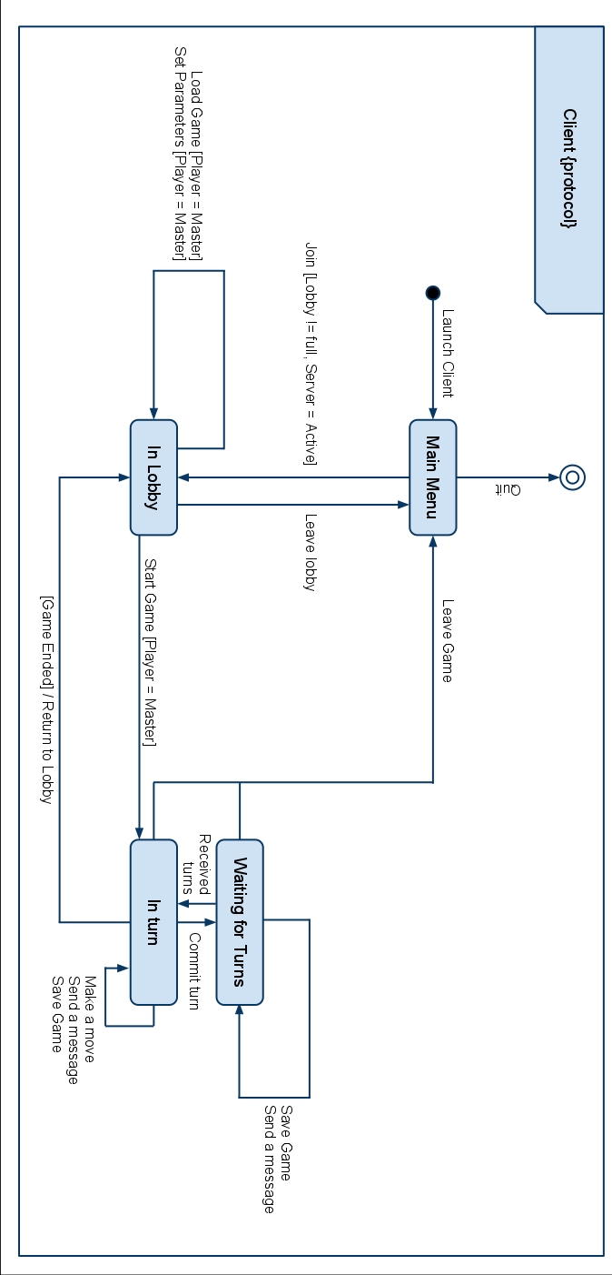
Figure 15: Protocol Model (Client)

The following diagram represents the different states the Server can be in, and which actions performed by the host will make the system change state.
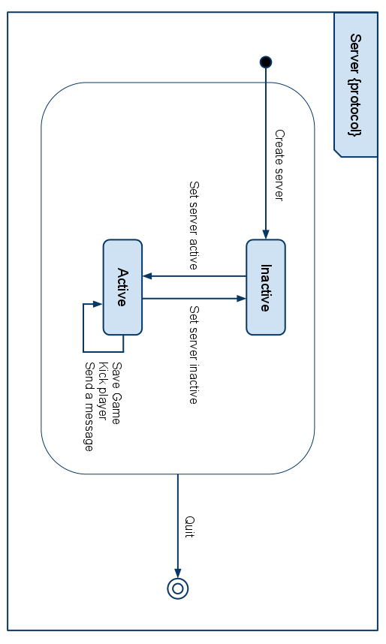
Figure 16: Protocol Model (Server)

